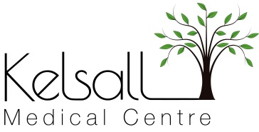
PRIVATE WORK
Some services provided are not covered under our contract with the NHS and therefore attract charges. Examples include the following:
- Medicals for pre-employment, certain sports and driving requirements (HGV, PSV etc.)
- Insurance claim forms
- Prescriptions for taking medication abroad
- Private sick notes
- Vaccination certificates
- Private Referrals
- To Whom it May Concern Letters

The fees charged are based on the British Medical Association (BMA) suggested scales and our reception or administration staff will be happy to advise you about them along with appointment availability where necessary. We advise patients that all fees must be paid in advance and to allow 20 working days for the completion of work once payment has been received.
We also offer private medicals which may be needed by any agency such as your employer or for overseas visa applications. Please contact the Practice and speak with a member of our reception or administration team for further information.
With immediate effect the practice will not undertake private work relating to any sports deemed Extreme. Examples include the following:
- Skydiving
- Scuba Diving
- Snow Boarding
- Motorsports
- Climbing
- Jockeying
- Marathon Running
- Jet Sports
If you require a sports medical certificate in relation to an extreme sport, there are a number of private medical care alternatives available to you. Examples include the following:-
Medicalcert.co.uk
Just Health Medicals

